152 Palmer Dr.
Cedarville, OH 45314

Dear,

It has been said, “All good things must come to an end.” However every “end” can be looked at as a new beginning as well. This past year can be defined for me primarily as “a year of transition.”

I have spent this last year as a Cedarville graduate working at Cedarville. As you may remember, I was blessed to receive a full time position working in our Snack Shop as the night manager. Many people have asked me, “What is it like to be alumni and staying at CU?” Honestly, it has prepared me for the next chapter of my life. As I began to determine the Lord’s leading in my future two areas of interest surfaced: teaching Bible, and working at the Eleuthera Bible Training Center. Therefore, I have applied to Dallas Theological Seminary to earn a ThM (Masters of Theology) and I was accepted this past December. I will be attending there in the fall. To continue my involvement at the Bible Training Center I have decided to go back to Eleuthera for May and June and serve on staff.
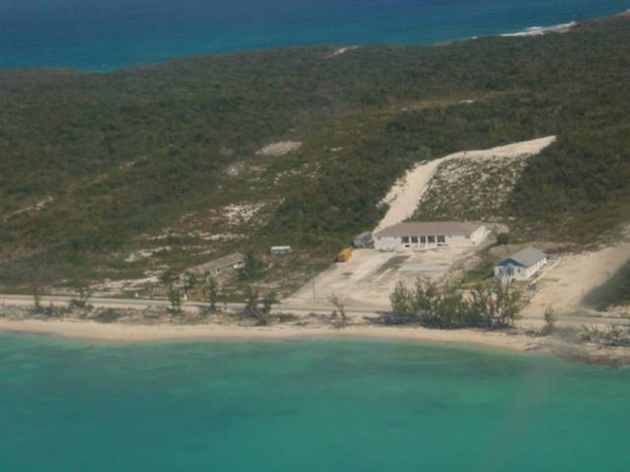
Perhaps you have heard of the Eleuthera Bible Training Center (EBTC). It began in the early 1990’s with an idea to train Bahamians in Biblical teaching and preaching at an affordable price in their local culture and setting. Today, the missionaries are ready to graduate their first class of students in May.

I was blessed to help lead the first Cedarville MIS team there 3 years ago. I have since then served off and on for 8 months, and this summer will be my 5th trip back. I am very excited to have been given the chance to go back and continue the relationships I’ve developed with the missionaries and nationals there. The campus there has grown over the summers and soon there will be two new buildings finished and ready for use. In my time there I have lead worship for teams and churches, worked construction from dawn to dusk, organized Vacation Bible Schools for youth, and preached in churches and small groups. The atmosphere there is extremely encouraging for spiritual growth and devotion to our Lord.
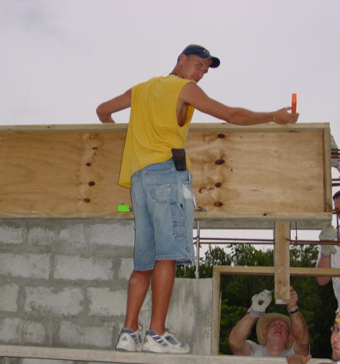
I will be working with existing missionaries Paul and Lisa Voss to help assist them in their duties. They have become mentors to me and I consider them my close friends. I am looking at EBTC as a strong career potential for future service, and having been a mission’s major from Cedarville University I have learned to value encouraging, uplifting missionary co-workers. During this time of transition from the familiar and comfortable Cedarville to the streets of Dallas and challenges of mission work, I need your prayer support. At the bottom is a reference bookmark; a picture and prayer requests you can tear off and post anywhere as a reminder to pray for me.

Secondly, if it is at all possible for you to help provide financial support for this ministry, it would be greatly appreciated. Any help to defray the cost of the $1000 expense for housing, supplies and food would be incredibly supportive, even if it’s just 10-20 dollars. If you feel inclined to do so, just fill out a check payable to POM/EBTC and mail the donation to POM/EBTC PO Box 23408 Chattanooga, TN 37422. Pressing On Ministries is the missions department for EBTC. I’ll even cover your postage!

I have been sending support letters out to family and friends for a few years now and I have developed a “newsletter” of sorts. If you would like I’ll include you on my mailing list so that no matter where I’m at on the globe you’ll receive up dates. Please send me an e-mail if you would like to continue receiving updates!

I am so encouraged to hear from friends about what’s new, so if you’re interested in contacting me or would like to ask me any questions you can reach me electronically at…

ryan_flunker@hotmail.com

or Snail Mail (until I move to Dallas) at…

152 Palmer Dr.
Cedarville, OH 45314

Thanks for your prayers and support, you have been an encouragement to me. I hope this letter finds you seeking the Lord’s will and enjoying life!

Sincerely,

Ryan Flunker

tear here
- - - - - - - - - - - - - - - - - - - - - - - - - - - - - - - - - - - - - - - - - - - - - - - - - - - - - - - - - - - - -
Ryan Flunker to Eleuthera 2004
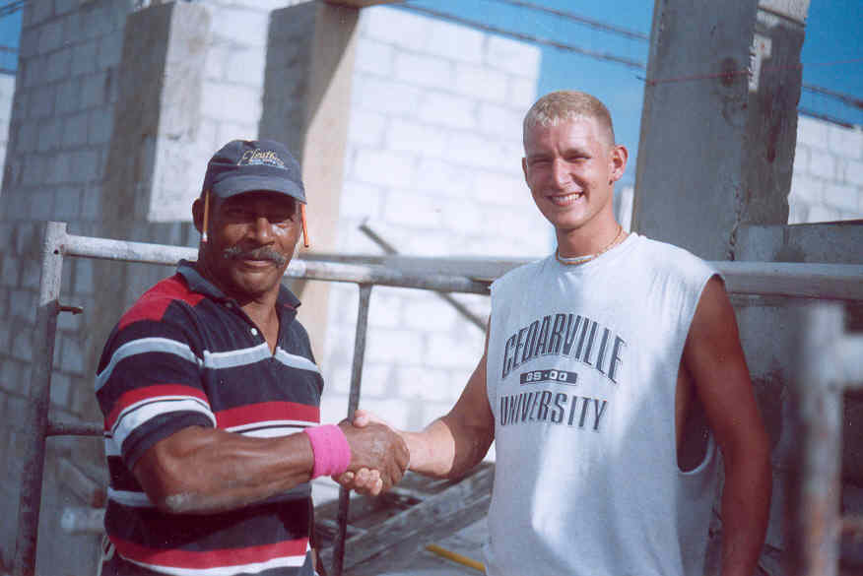
Prayer Requests:

- The transition to becoming a seminary student
- Financial support for serving in Eleuthera
- Safety in traveling: airplane, highway, etc…
- Long term dedicating to teach Bible over seas
- The Eleuthera Bible Training Center: More workers needed, more support needed

